

Lab Sheet 2

Database Management System Lab (BTCS203P)
B. TECH AI&ML, CYBER SECURITY, Data Science 3RD Semester (Session 2026-2025)

Objective:
To understand and practice Data Manipulation Language (DML) commands for creating and modifying the structure of a table in a relational database using SQL (MySQL).

Prerequisites:
- Basic knowledge of SQL.
- MySQL installed and set up.

Lab Sheet 2: DML Commands – INSERT, UPDATE and DELETE Perform the following SQL tasks using suitable examples:
- Insert one record into the Student table.
Insert into Student values('Yash', 22, 'Data Science', '2004-07-26', 'B.Tech', 2022,'Meerut');
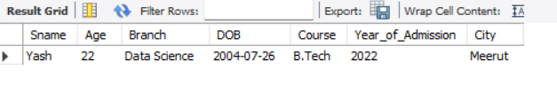

- Insert five student records using separate INSERT statements.
Insert into Student v-- alues('Pooja', 19, 'Civil', '2007-08-11', 'B.Tech', 2025);
-- Insert into Student values('Arjun', 22, 'Mechanical', '2004-05-30', 'B.Tech', 2022);
-- Insert into Student values('Kavya', 20, 'AI', '2006-09-21', 'B.Tech', 2024);
-- Insert into Student values('Nikhil', 21, 'ECE', '2005-02-17', 'B.Tech', 2023);
-- Insert into Student values('Mehak', 19, 'CSE', '2007-11-03', 'B.Tech', 2025);
-- Select * from Student;
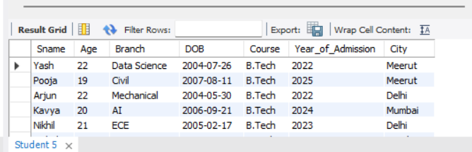

- Insert multiple records into the Student table using a single statement.
Insert into Student (Sname, Age, Branch, DOB, Course, Year_of_Admission,City)
VALUES
('Pooja', 19, 'Civil', '2007-08-11', 'B.Tech', 2025,'Meerut'),
('Arjun', 22, 'Mechanical', '2004-05-30', 'B.Tech', 2022,'Delhi'),
('Kavya', 20, 'AI', '2006-09-21', 'B.Tech', 2024,'Mumbai'),
('Nikhil', 21, 'ECE', '2005-02-17', 'B.Tech', 2023,'Delhi'),
('Mehak', 19, 'CSE', '2007-11-03', 'B.Tech', 2025,'Roorkee');

- Insert records into the Employee table.
INSERT INTO Employee (FirstName, LastName, Department, Salary, Email)
VALUES
('Suhani', 'Saini', 'BTech', 60000, 'suhani@gmail.com'),
('Amit', 'Sharma', 'IT', 55000, 'amit@gmail.com'),
('Priya', 'Verma', 'HR', 50000, 'priya@gmail.com');
Select * from Employee;
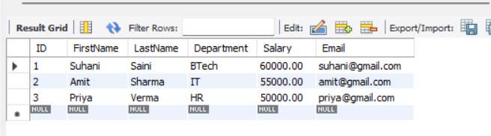

- Insert records into the Department table.
CREATE TABLE Department (
Dept_ID INT AUTO_INCREMENT PRIMARY KEY,
Dept_Name VARCHAR(50) NOT NULL,
Location VARCHAR(50)
);
INSERT INTO Department (Dept_ID, Dept_Name, Location)
VALUES
(101, 'CSE', 'Block A'),
(102, 'IT', 'Block B'),
(103, 'ECE', 'Block C'),
(104, 'HR', 'Block D');
Select * From Department;
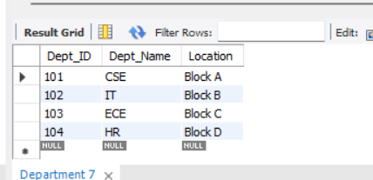

- Insert records into the Product table.
CREATE TABLE Product (
Product_ID INT AUTO_INCREMENT PRIMARY KEY,
Product_Name VARCHAR(100) NOT NULL,
Price DECIMAL(10,2),
Quantity INT
);
INSERT INTO Product (Product_ID, Product_Name, Price, Quantity)
VALUES
(1, 'Laptop', 55000, 10),
(2, 'Mouse', 500, 50),
(3, 'Keyboard', 1000, 30),
(4, 'Monitor', 12000, 15);
Select * From Product;
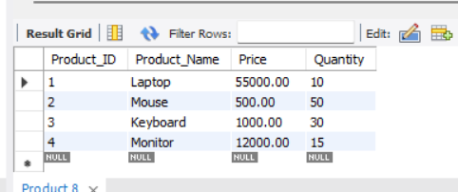

- Insert records into the Customer table.
INSERT INTO Course (Course_ID, Course_Name, Duration, Fees)
VALUES
(101, 'BTech CSE', '4 Years', 120000),
(102, 'BTech IT', '4 Years', 115000),
(103, 'BTech Data Science', '4 Years', 130000),
(104, 'BCA', '3 Years', 90000);
- Insert records into the Course table.
INSERT INTO Course (Course_ID, Course_Name, Duration, Fees)
VALUES
(101, 'BTech CSE', '4 Years', 120000),
(102, 'BTech IT', '4 Years', 115000),
(103, 'BTech Data Science', '4 Years', 130000),
(104, 'BCA', '3 Years', 90000);
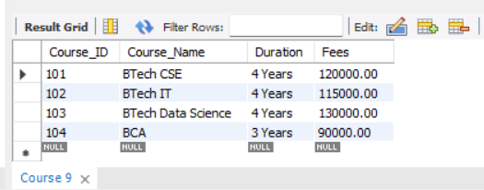

- Insert a student record with values for all columns.
INSERT INTO Student (Sname, age, branch)
VALUES ('Riya', 19, 'CSE');
Select * from Student;
- Insert a student record by specifying only selected columns.
UPDATE Student
SET Year_of_Admission=2022
WHERE Sname = 'Rahul';
- Update the city of a particular student.

- Update the salary of a particular employee.
UPDATE Employee
SET Salary = 65000
WHERE ID = 1;
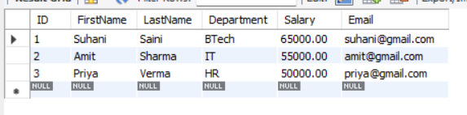

- Increase the salary of all employees by 10%.
UPDATE Employee
SET Salary = Salary * 1.10;
- Increase the price of all products by 5%.

- Change the course of a particular student.
UPDATE Student
SET Course = 'BTech CSE'
WHERE Sname = 'Rahul';
- Update the department of an employee.
UPDATE Employee
SET Department = 'CSE'
WHERE ID = 1;
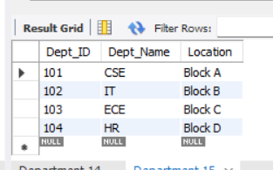

- Update the city of all students from Meerut to Delhi.
UPDATE Student
SET City = 'Delhi'
WHERE City = 'Meerut';
- Update the fees of a particular course.
UPDATE Course
SET Fees = 140000
WHERE Course_Name = 'BTech Data Science';
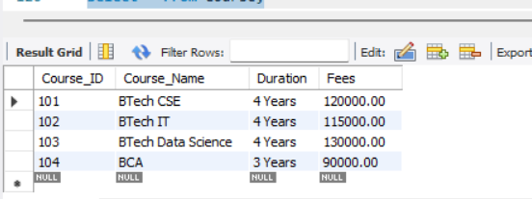

- Update multiple columns of a student simultaneously.

- Delete a particular student record using Student_ID

DELETE FROM Student
WHERE Year_of_Admisssion=2025;
- Delete all students belonging to a particular city.
DELETE FROM Student
WHERE City = 'Meerut';
- Delete employees whose salary is below a specified amount.
DELETE FROM Employee
WHERE Salary < 50000;
- Delete products whose quantity is zero.
DELETE FROM Product
WHERE Quantity = 0;
- Delete records satisfying multiple conditions using AND/OR.
- Perform a complete sequence of INSERT, UPDATE and DELETE operations on a Student table and display the table after each operation.
INSERT INTO Student
VALUES ('Rahul', 21, 'CSE', '2005-04-15', 'B.Tech', 2023, 'Jaipur');

SELECT * FROM Student;
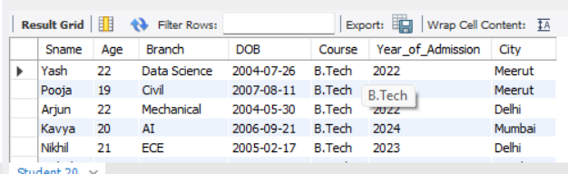

UPDATE Student
SET City = 'Delhi'
WHERE Sname = 'Yash';

SELECT * FROM Student;

DELETE FROM Student
WHERE Sname = 'Rahul';

SELECT * FROM Student;

